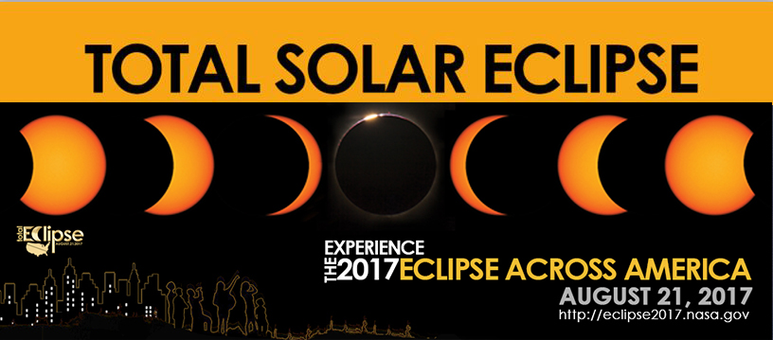

On August 21, 2017, a total solar eclipse will cross the continental United States from Salem, Oregon to Charleston, South Carolina. The last time a total eclipse crossed the United States from sea to sea was June 8, 1918. The 2017 eclipse in either total or partial phase can be seen by over 500 million people in North and South America, Europe, and Africa. In the U.S., millions will gather along a tiny ribbon less than 100 miles wide to see totality, the complete blocking out of the sun by the Moon which will reveal the solar corona. The rest of entire country will be able to see a partial eclipse. It is also truly an historic event and a wonderful opportunity to view one of nature's most stunning displays.

WHEN:
TIME:
WHERE:
Your Event Date / Month and Year
Your Event Time
Your Event Address/Tel #

TO SEE MAPS, RESOURCES, COMMUNITY ACTIVITIES, LIVE COVERAGE AND MORE, GO TO HTTP://ECLIPSE2017. NASA.GOV

