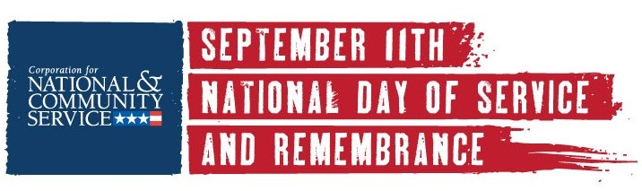
FOR IMMEDIATE RELEASE CONTACT: [NAME]
September [XX], 2019
[PHONE, EMAIL]

Residents Honor 9/11 Day with American Tradition of Service

[CITY, STATE] – [HUNDREDS] of [CITY] residents will join in patriotic acts of service to mark the anniversary of the 9/11 attacks during the September 11th National Day of Service and Remembrance. Volunteers will [INSERT SHORT DESCRIPTION OF PROJECT], joining hundreds of thousands of citizens across the country in this American tradition.
[LOCAL PROJECT SPECIFIC INFORMATION]

“September 11th is a day of history, emotion, and reflection,” said [ORGANIZER], the [TITLE] of [ORGANIZATION]. “For many Americans it is also a day of service that provides an opportunity for citizens to put into action a shared belief that by joining our neighbors and local leaders we can make our country stronger and better for decades to come while we honor those who lost their lives in 2001 and those who rose in service to our country.”

September 11th was designated a National Day of Service by Congress in 2009 and is led by the Corporation for National and Community Service (CNCS), the federal agency that engages millions of Americans in service through its AmeriCorps and Senior Corps programs and is responsible for the nation's volunteering and service efforts. For more information, visit NationalService.gov.

CNCS partners with 911Day.org and hundreds of business, nonprofit groups, faith-based organizations, and schools nationwide.

This year, thousands of volunteers of all ages and backgrounds in both rural and urban communities are expected to join their neighbors in delivering meals, repairing homes of veterans and military families, refurbishing schools and community centers, preparing care boxes for the military and first responders, collecting food and clothing, signing up as mentors, reading to children, and more.

###

[ABOUT YOUR ORGANIZATION]

